**Portfolio Website**

**Preparations and Submission Details**

* **The deadline** will be on Thursday in 2nd week at 23.59 (WIB)
* Link to submit the assignment [here](https://rebrand.ly/FCSWE-miniproject) (will be opened on Wednesday week 2)

**Introduction**

In this ten-day short course, you’ll learn all about becoming a software engineer, including the career path possibilities. We’ll also give you the opportunity to practice the main responsibilities of a software engineer as well!

Before you start...

1. Make sure you have downloaded **Visual Studio Code, Git** and have access to **Google Chrome**

**Mini Project Instructions**

As Software Engineer, you are asked to create a website of the school profile with a designated form to get your stakeholders' personal information and inquiries (Name, Email, Phone Number, and Message) by using JavaScript validation. Create a website using the [mockup](https://app.moqups.com/Y8iumYO1yOg5P2v9YSZ4pW7u8Hs15D2s/view/page/a488d45e5) design below:

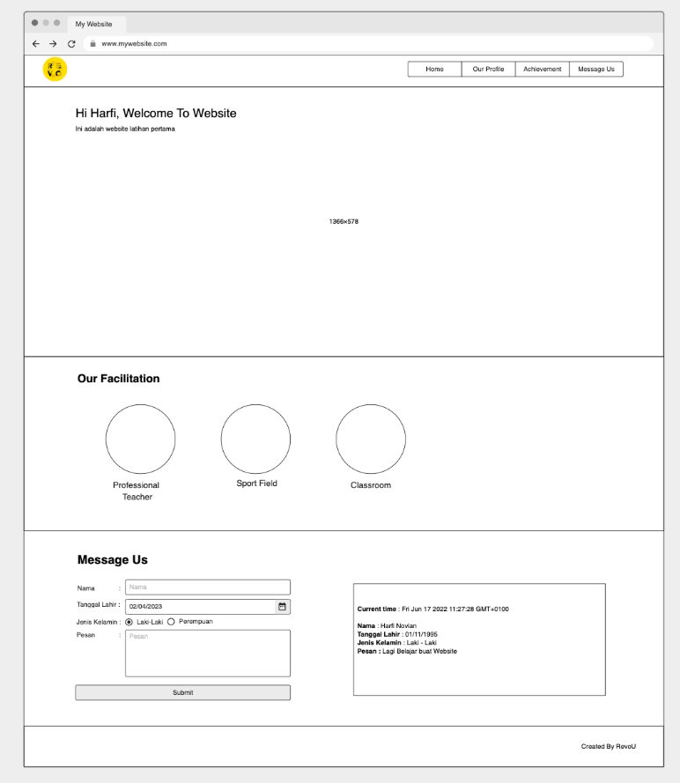

Workflow:

1. Slicing according to the mockup above and completing the profile page using your own design, but still consisting of a “banner for background”, “about your school”, and “Vision & Mission".
2. Profile page can navigate from navbar “Our Profile”
3. “Our Profile” design created by your creativity but must include complete information.
4. Welcoming speech on Home Page “Hi Name” is use JavaScript for fill the “Name”
5. Validate Form “Message Us” & show value when submit form on the HTML with JavaScript
6. Implement Responsive Design on each page (on Desktop and Mobile)
7. Put css file inside of the css/ folder
8. Please only put only 1 css for the entirety of the project
9. Put javascript files inside the js/ folder
10. Please put only 1 javascript file for the entirety of the project
11. After finish your website, upload Source Code in [GitHub Classroom](https://rebrand.ly/fcse-github) and publish the website in [Github Pages](https://pages.github.com/)
12. Submit URL repository and published website through dedicated [Typeform submission](https://rebrand.ly/FCSWE-miniproject) that will be opened on Wednesday week 2

**Expected file structure:**